Visual Story for the
Relaxed Performance of The Man Who Wanted to be a Penguin

Saturday 8th January 2022 at 11am

This Visual Story is designed for visitors to the Relaxed Performance of The Man Who Wanted to be a Penguin. This guide should help prepare you for your visit, understand what to expect during the pantomime and help you find your way around the Theatre Royal Plymouth.

General Information about the Theatre Royal Plymouth

This is what the Theatre Royal Plymouth looks like from the outside. You will come into the foyer (inside area) through the sliding doors.

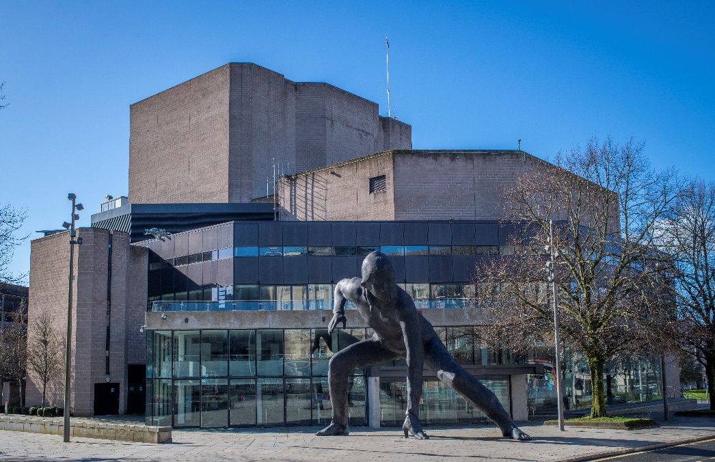

The foyer can get busy before the show. There are places where you can sit down if you arrive early.

The Box Office looks like this. If you need help with your tickets please go here. We are now using digital tickets so you will be able to access these on your mobile phone. See the end of the visual story for more information on digital tickets and our Covid-Safe environment.
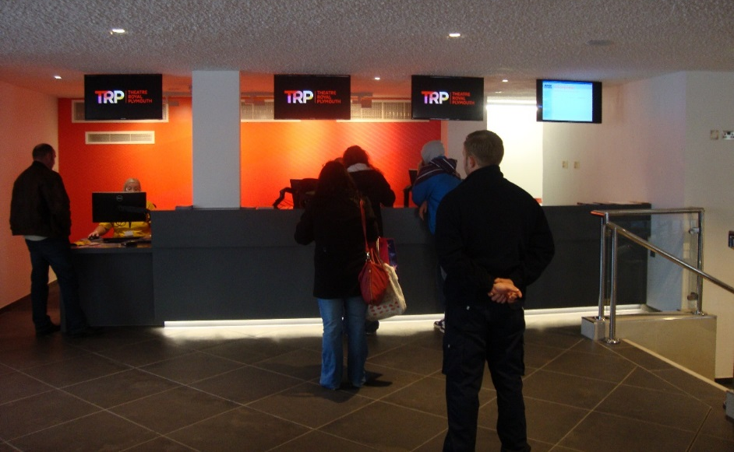

Toilets

There are toilets on every floor of the theatre, including accessible toilets suitable for wheelchair users.

The accessible toilet on the second floor requires a radar key, please contact a member of staff if you need it.

Theatre Royal Plymouth staff

When you arrive at the theatre there will be welcome hosts who will scan your tickets on your phone. There is also a temperature check point at the entrance.

Please wear a face covering when attending the theatre unless you are exempt.

The welcome hosts and ushers will answer any of your questions, help you find your way around and show you where to go to find your seats.

The Theatre Royal Plymouth staff are always happy to help and answer any questions. They wear a uniform which looks like this:

You can also ask questions to anyone wearing a Theatre Royal Plymouth lanyard around their neck.

The Auditorium

The auditorium is the part of the theatre where the audience will sit while they watch The Man Who Wanted to be a Penguin.

The door number that you need to go to find your seats is on your e-ticket.

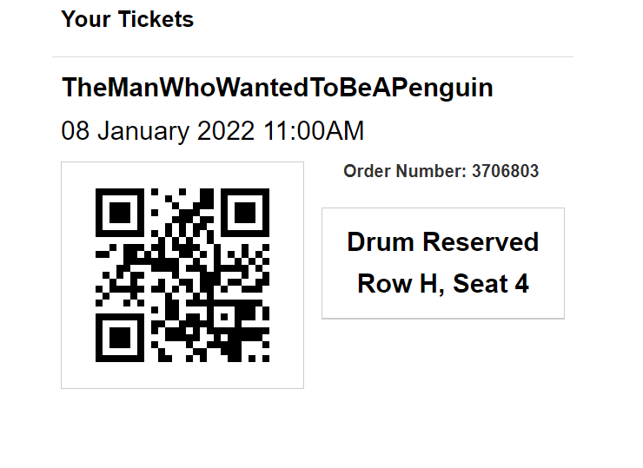
This is the part of auditorium where you will sit, along with which row you are on and your seat number

The doors will be left open during the performance so you can easily leave if you need to.

The Drum auditorium looks like this:
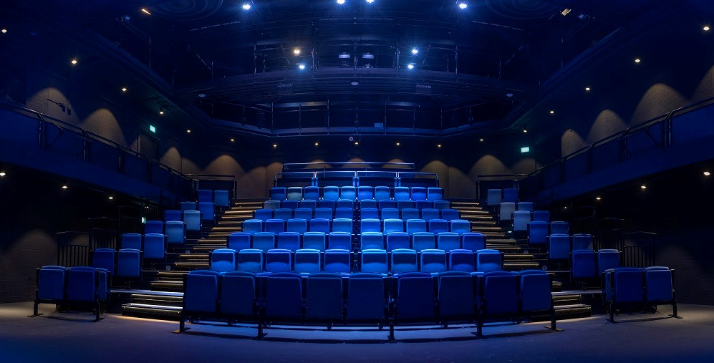

Here is a seat map of The Drum auditorium which will help you find your seats.
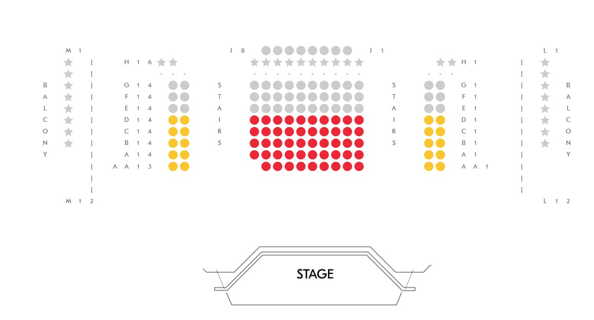

Entrance to The Drum auditorium

You will have time before the performance starts to find your seats and get comfortable.

During the performance

The main lights in the auditorium will stay on.

There will not be any loud bangs.

You can talk and don’t have to be quiet.

If you would like to have a break and leave the auditorium, there will be a chill out zone on the ground floor where you can sit and relax.

The performance will also be BSL interpreted.

How long does The Man Who Wanted to be a Penguin last?

The Man Who Wanted to be a Penguin will start at 11:00am and last for around 1 hour.

About The Man Who Wanted to be a Penguin
The Man Who Wanted to be a Penguin is a special kind of show which uses puppets and two actors to tell the story. The characters in the story are sometimes played by the puppets and sometimes played by the actors.
The main character of the show is an enthusiastic, energetic and curious man. The tale begins with him in his garden shed inventing solutions to problems. This character is played by one of the two actors.
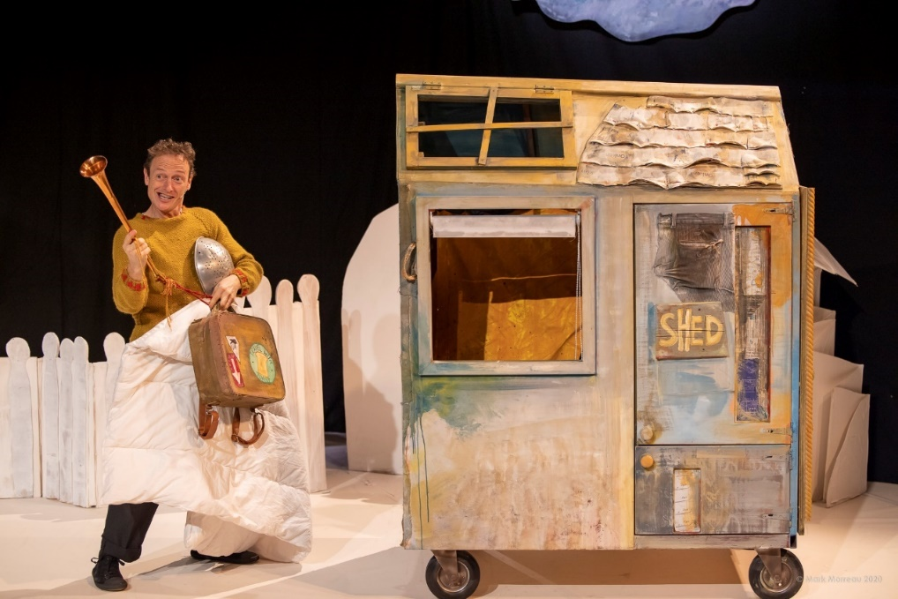

The second actor will play lots of different characters, including several of The Man’s neighbours and even the local postman!
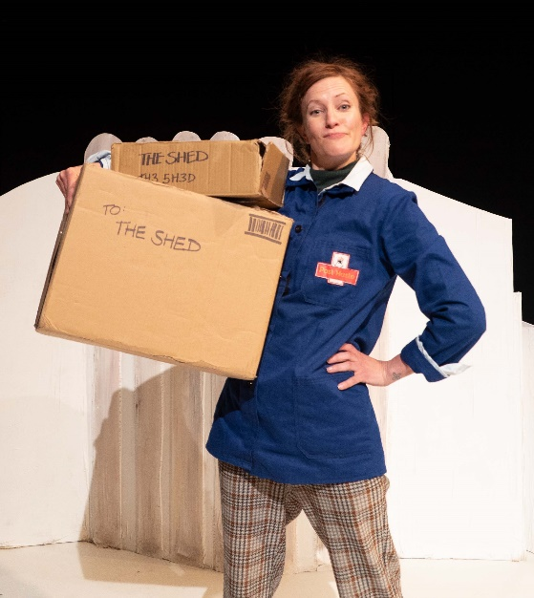
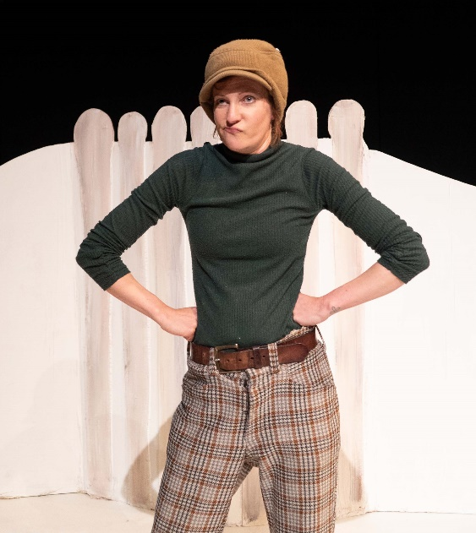

The Man is fascinated by penguins, and plans to meet them when he decides to travel to the Antarctic.
You will see him learn to speak some penguin language before he goes. You’ll even have a chance to learn penguin language with him!
When The Man arrives at the Antarctic, he joins a community that works differently to the one he knows at home, and that accepts him for who he is.
This is the part of the show where you’ll meet lots of penguins! You will see penguin puppets pop up all around the stage.
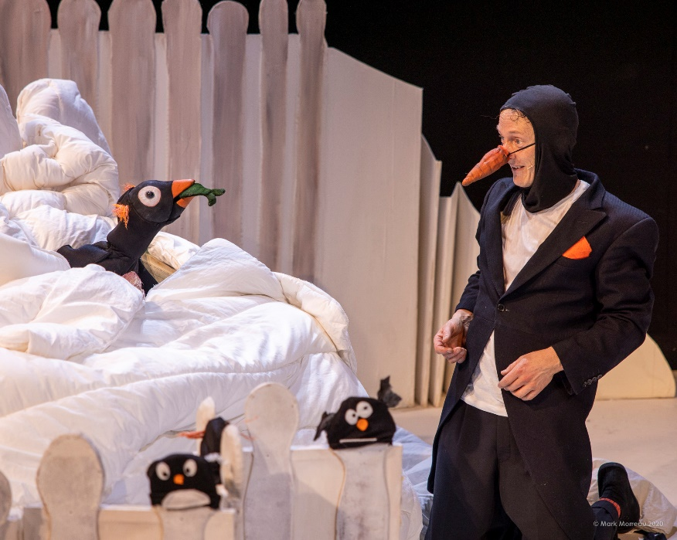

Although it all may seem very real, it isn’t, the actors are telling a story.
During the show there will be some music. If it is too loud, you can cover your ears, or wear your headphones. There will also be some flickering effects and snow effects.

During the show some people will clap. Clapping makes the actors happy because it means people are enjoying the show. If you want to clap then you can. You don’t have to clap if you don’t want to.

At the end of the show, the actors will come out on stage. After this the actors will bow. Many people will clap a lot so the actors know how much they liked the show.

After the show is over, everyone will leave the theatre.

We hope you enjoy the show and have a fantastic 2022!

Further relaxed performances at Theatre Royal Plymouth

Aladdin
Thursday 13th January 2022 12.30pm

