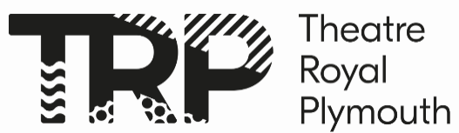

COMPANY15 Application Form
Please fill out this form to apply for COMPANY15 2026. The deadline is Friday 9th January 2026. All applications will be reviewed after this deadline date, and not before. After we review the applications, we will be in touch to invite you to a workshop interview.

Address:

Email:

Phone Number:

Current school/college:

School year:

Age:

Why would you like to take part in Company15? (250 words max)
We would like to know why Theatre Royal Plymouth and why this programme.

What qualities and skills could you bring to Company15 in terms of working with other young people and staff at the Theatre Royal Plymouth? (250 words)

What support do you think you might need for you to get the most out of this placement?
If you feel you might need support in some way, we’d love to know, so that we can do our best to provide that.

Please tell us, if you could do any job at the theatre, what would you do and why? If you’re not sure, what inspired you to apply for this placement and what you’d like to get out of it. (500 words max)
There’s no right or wrong answer here, we just want to hear from you- in your own words- it’ll help us to get you to know you better.

Thank you for your application! We will be in touch after Friday 9th January to invite you to a workshop interview.

